* **Exercise 01:**

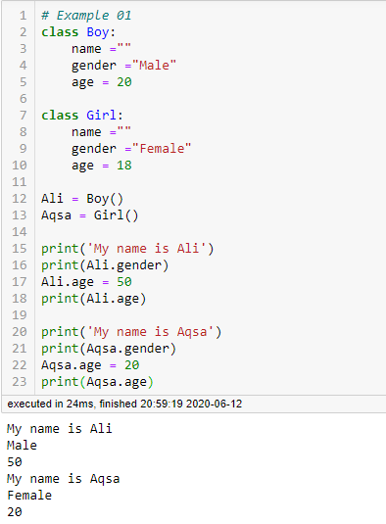

* **Exercise 02:**

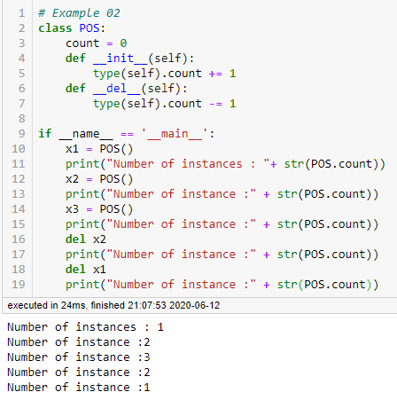

* **Exercise 03:**

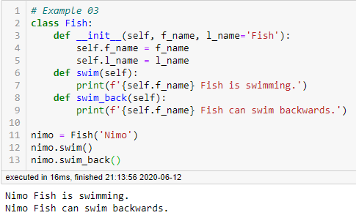

* **Exercise 04:**

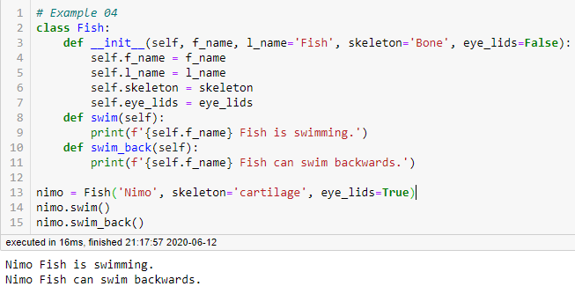

* **Exercise 05:**

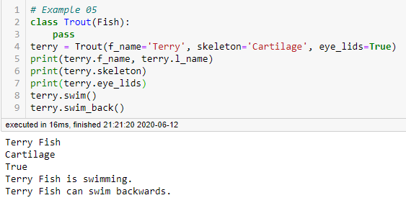

* **Exercise 06:**

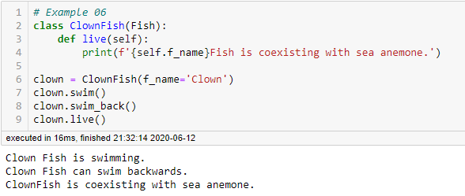

* **Exercise 07:**

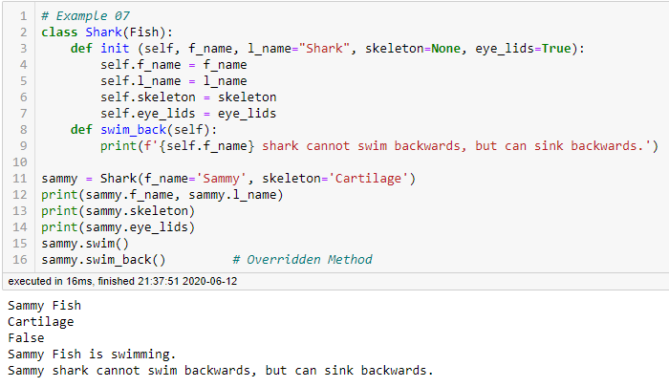

* **Exercise 08:**

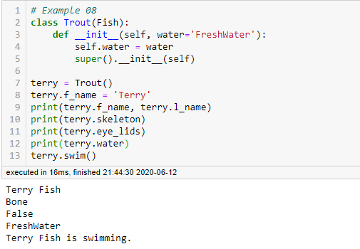

* **Exercise 09:**

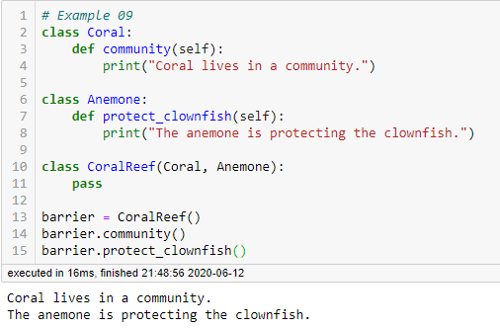

* **TASK 01:**
* **Inheritance:** Inheritance is a feature used in object-oriented programming; it refers to defining a new class with less or no modification to an existing class. The new class is called derived class and from one which it inherits is called the base. A class can inherit attributes and behavior methods from another class called subclass.
* **Multiple Inheritance:** When you inherit a child class from more than one base classes, that situation is known as Multiple Inheritance. It, however, exhibits the same behavior as does the single inheritance. The syntax for Multiple Inheritance is also similar to the single inheritance. By the way, in Multiple Inheritance, the child class claims the properties and methods of all the parent classes.
* **Multilevel Inheritance:** We can also inherit from a derived class. This is called multilevel inheritance. It can be of any depth in Python. In multilevel inheritance, features of the base class and the derived class are inherited into the new derived class.
* **Super Function:** Super function provides us the facility to refer to the parent class explicitly. It is basically useful where we have to call superclass functions. It returns the proxy object that allows us to refer parent class by ‘super’.

Super function provides us the flexibility to do single level or multilevel inheritances and makes our work easier and comfortable. Keep one thing in mind that while referring the superclass from subclass, there is no need of writing the name of superclass explicitly.

* **TASK 02:**

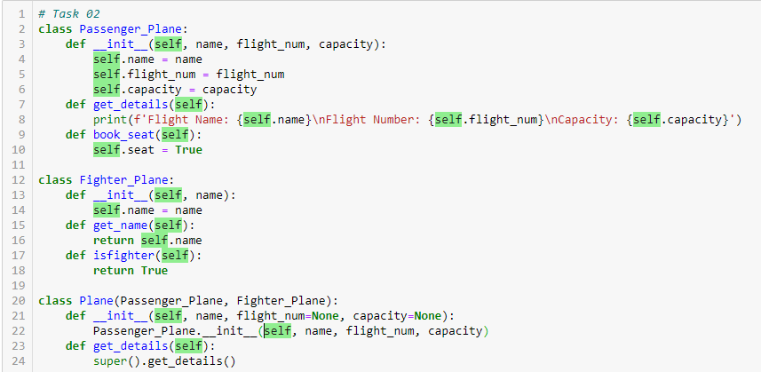

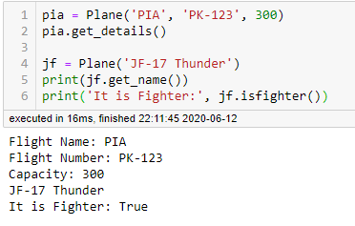

* **TASK 03:**

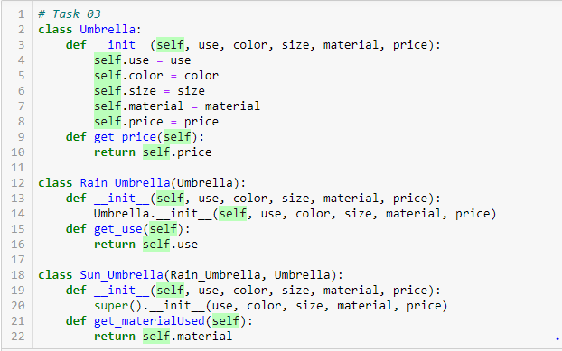

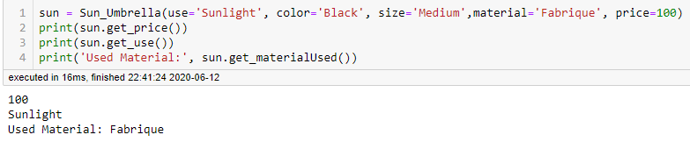

**THE END**